Second Circular and Call for Papers
CASE´2019
The 9th Catalysis and Sensing for Our Environment Symposium 2019

14-16 April 2019

Northwest A&F University

22 Xinong Avenue, Yangling, Xi’an

Shaanxi 712100, China

CONTENTS

Invitation 2
Aims and Scope 2
Symposium Chairs 2
Academic Committee 2
Local Organizing Committee 3
Fund Raising Committee 3
Invited Lectures 3
Conference Venue & Accommodation 4
Registration 4
Important Dates 4
Sponsors 5
Contact Information 5
Registration Form 5
Traffic Information 6

Invitation
On behalf of the organizing committee of the 9th Catalysis and Sensing for Our Environment Symposium 2019 (CASE 2019) to be held at the beautiful city of Yangling, China from April 14-16 (14 for registration) 2019, we warmly invite you to participate in this Symposium.
We hope that through the symposium you will turn inspiration into fruitful investigations, make new friends, and renew old friendship.
Looking forward to meet you at Yangling!

Aims and Scope
This symposium is organized by Northwest A&F University, Nanjing University, and Chinese Chemical Letters (CCL) together.
Since its foundation in 2008 the symposium has been hosted by Prof. Tony James, John Fossey, Steven Bull, Xuhong Qian, Shuli You, Eric Anslyn, Jonathan Sessler, Yunbao Jiang, Thorri Gunnlaugson, Donal O’Shea and Yufang Xu. It has become an important event in the scientific calendar and previous symposia have been held in: The University of Bath (UK, 2008); East China University of Science and Technology (China, 2009); The University of Birmingham (UK, 2011); Shanghai Institute of Organic Chemistry (China, 2012); University of Texas at Austin (USA, 2013); Xiamen University (China, 2014); Trinity College Dublin/Royal College of Surgeons (Ireland, 2015), and Shanghai Second Polytechnic University (China, 2017). CASE 2019 program will bring together researchers from China, Ireland, UK, and other countries in high profile and dynamic research areas.
The scientific program features oral presentation and poster sessions, an exhibition, and ample opportunities for attendees to network. Oral presentations are mainly made by invitation, there will be limited talk slots reserved for those who prefer oral presentations. Poster sessions will be an important part of the program. All attendees will have the opportunity of presenting their posters in evenings. A one-page abstract for each poster will be included in the abstract book.

Symposium Chairs
Zhichao Pei (Northwest A&F University)
Leyong Wang (Nanjing University)

Academic Committee
(Alphabetically)
Eric Anslyn (University of Texas at Austin, USA)
Steven Bull (University of Bath, UK)
Tony James (University of Bath, UK)
John S. Fossey (University of Birmingham, UK)
Thorri Gunnlaugson (Trinity College Dublin, Ireland)
Yunbao Jiang (Xiamen University, China)
Zhicao Pei (Northwest A&F University, China)
Xuhong Qian (East China Normal University, China)
Jonathan Sessler (University of Texas at Austin, USA)
Donal O’Shea (Royal College Surgeons in Ireland, Ireland)
Shuli You (Shanghai institute of Organic Chemistry, CAS, China)
Yufang Xu (Shanghai Second Polytechnic University, China)
Leyong Wang (Nanjing University, China)

Local Organizing Committee

Members:
Zhichao Pei (Northwest A&F University):
Leyong Wang (Nanjing University)
Yuxin Pei (Northwest A&F University)
Xiao-Yu Hu (Nanjing University of Aeronautics and Astronautics)

Secretary: Yuxin Pei (Northwest A&F University)

Fund Raising Committee
Yuxin Pei (Northwest A&F University)

Invited Lectures
(Alphabetically)
Engin Umut Akkaya, Bilkent University

Ben Buckley, Loughborough University
Steve Bull, University of Bath
Stephen Butler, Loughborough University
Wen-Sheng Chung, National Chiao Tung University
Kin Shing Chan, the Chinese University of Hong Kong

Xiuling Cui, Huaqiao University
Scott Dalgarno, Heriot-Watt University

John S. Fossey, University of Birmingham

Tony D. James, University of Bath

Yitao Long, Nanjing University
Rebecca Melen, Cardiff University
Xiaojun Peng, Dalian University of Technology
Adam Sedgwich, Utexas University of Texas-Austin
Jihao Su, TianjinUniversity
Xiaolong Sun, Xi’an Jiaotong University
Tao Tu, Fudan University
Lin Xu, East China Normal University
Zhaochao Xu, Dalian Institute of Chemical Physics, Chinese Academy of Sciences
Youjun Yang, East China University of Science and Technology

Conference Venue & Accommodation
This symposium will be held the International lecture hall inside Northwest A&F University, which is close to Guest House. All the invited speakers will have accommodation at Guest House of NWAFU; While some participators may need stay at Yangling International Conference & Exhibition Center Hotel due to the limited rooms.
First reserved, first served.

Registration
Send abstract and registration form to Prof. Yuxin Pei at peiyx@nwafu.edu.cn and pay the registration fee online via Alipay or WeChat by scanning the QR codes before 15 March 2019, or cash on spot.

Registration Place on 14 April 2019
Guest House of Northwest A&F University. Address: No. 3 TAICHENG ROAD, YANGLING DISTRICT, SHAANXI 712100, CHINA （中国陕西省杨凌农业高新技术产业示范区邰城路3号，西北农林科技大学南校区外专公寓，邮编712100）.

Registration Fee*
Postgraduate students and postdoctoral researchers: 900 CNY (about 100 pounds or 110 Euro)
Academic: 1450 CNY
Industrial: 1800 CNY
*Meals and banquet fee included.



Payment by Alipay Payment by WeChat
Bank information:
Beneficiary name: Northwest A&F University
Beneficiary address: No. 3 Taicheng Road, Yangling, Shaanxi, PR China
Bank name: BANK OF CHINA LIMITED YANGLING SUB-BRANCH SHAANXI BRANCH CHINA
Bank address: No.2 Weihui Road, Yangling, Shaanxi, China
Swift code: BKCHCNBJ620
Account number: 102810820826

Important Dates
15 March 2019: Registration Deadline
15 March 2019: Abstract submission deadline
14-16 April 2019: Meeting (14 April for registration)
17 April 2019: Departure

Sponsors

Northwest A&F University

Chinese Chemical Letters

Contact Information

Professor Dr. Yuxin Pei
Secretariat of CASE 2019
College of Chemistry & Pharmacy

Northwest A&F University
22 Xinong Avenue, Yangling, Xi’an

Shaanxi 712100, China
Email: peiyx@nwafu.edu.cn (Yuxin Pei)
huxy@nju.edu.cn (Xiao-Yu Hu)
Tel: (+) 86-(0) 29-87091196 (O)
Fax: (+) 86-(0) 29-87092769 (O)
Symposium website: Coming Soon!

Registration Form
Speaker | First Name | Last name
Affiliation
Position
E-mail
Phone
Hotel | Arrival： | Departure:
Flight No.  (If possible) | Arrival： | Departure：
Flight No.  (If possible) | Arrival： | Departure：

Traffic Information

How to get to the guest house of Northwest A&F University

You can get there by

1) The high-speed rail: Yangling South Station. It takes 10 minutes by taxi.

2) Airplane: Xi'an Xianyang International Airport. It takes 90 minutes by bus （35 CNY）, 1 h by taxi (recommended

cost 350-550 CNY. We can arrange taxi for you if you need.).

Time table for the airport shuttle bus:

From Airport to Yangling: 9:30, 10:30, 12:30, 15:00, 16:30, 18:00.

From Yangling to Airport: 7:00, 10:00, 13:00, 14:00, 15:30, 17:00.

Service telephone: +86 29 8708 3251.

It is 20 minutes' walk from Yangling bus station to the guest house (the red star).
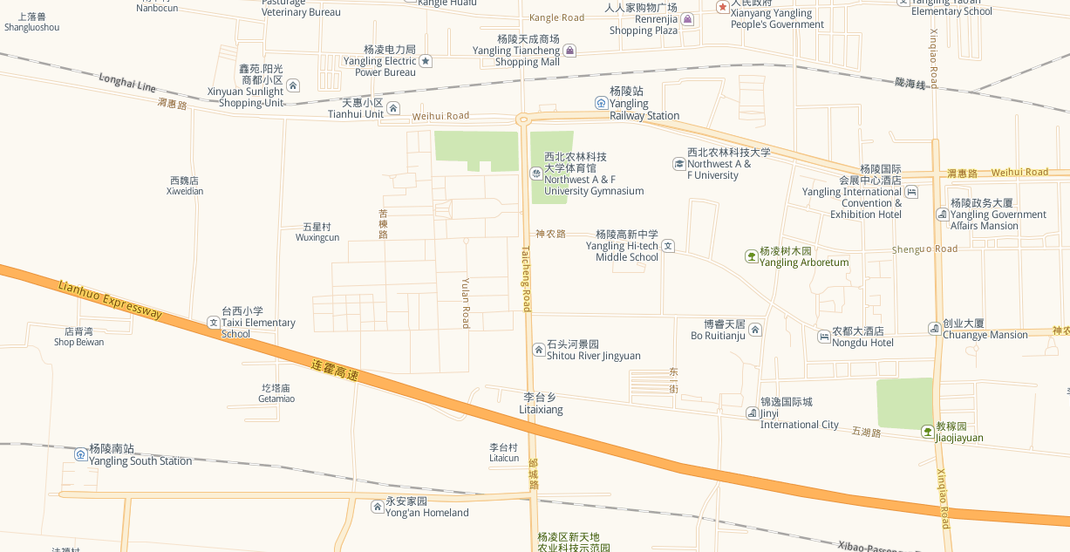
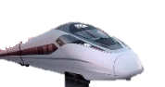

200m
Guest House of Northwest A&F University

